Use case Diagram

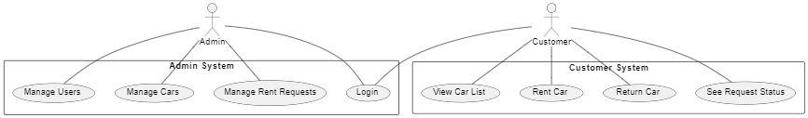

Class Diagram

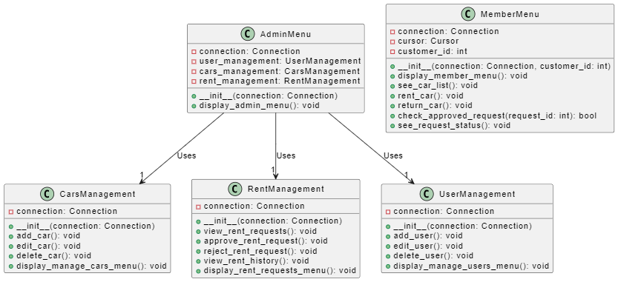

Sequence Diagram (User Management by Admin/Employee)

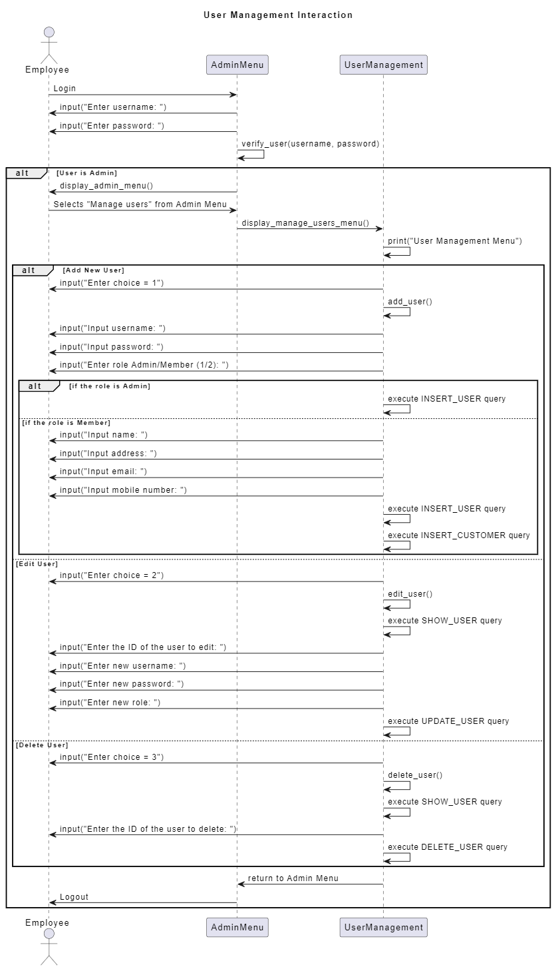

Sequence Diagram (Cars Management by Admin/Employee)

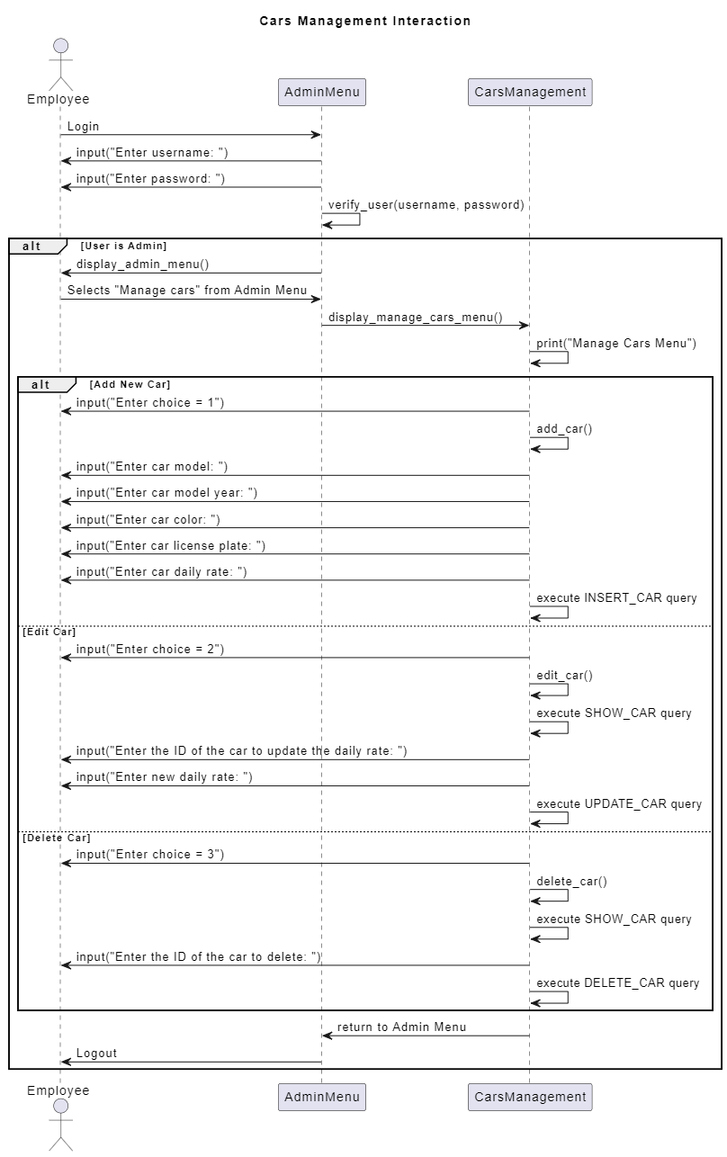

Sequence Diagram (Rent Management by Admin/Employee)

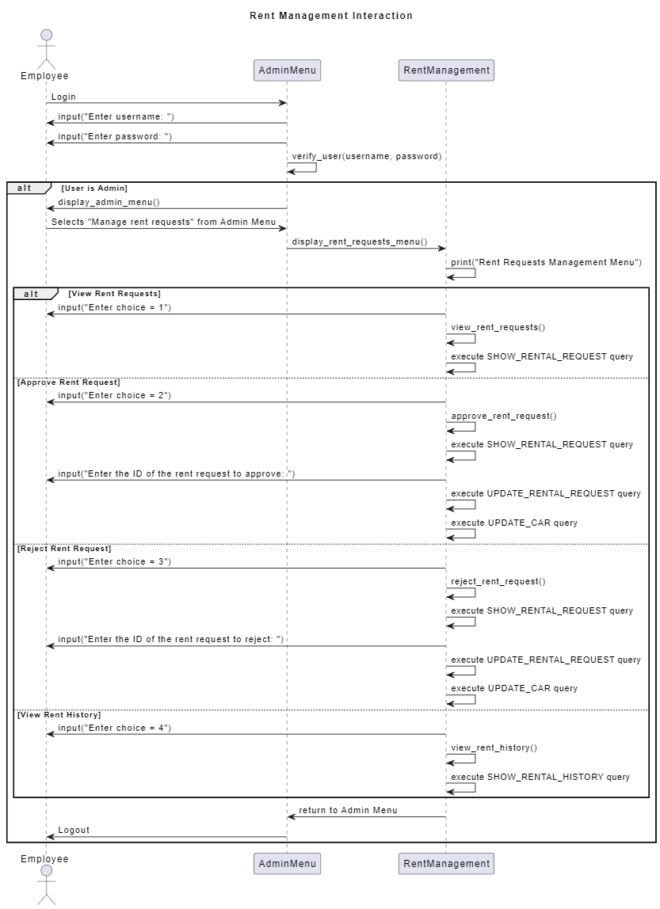

Sequence Diagram (Customer side)

